1. What are the benefits of using Text Block (more than four options were there and four has to be selected)?
2. Text can be formatted with different styles or sizes within the block
3. There can be links or images in the block
4. Tables arrange the text neatly
5. Text Blocks support merge codes for data
6. Which relationship model supports radial, Sankey, Hierarchical and TimeLine graph?
7. any Object Model
8. Party model
9. Many object Model
10. Which of the action is not present in OS?
11. Recalculate Action
12. Done Action
13. Email action (or PDF action - *forgot*)
14. Service Management layer is composed of which of the following components? (Choose two)
15. Omniscript
16. Card
17. Integration procedure
18. Data Raptor
19. What decided the field and actions displayed on the card?
20. Card layout
21. Card zones
22. Card state
23. How Vloicty is aligned with salesforce?(choose 2)
24. Native
25. Additive
26. Separate
27. As per the best practice suggested by Vlocity how many actions should be displayed on the card?
28. 10
29. No limit
30. 5
31. A table will be provided listing the actions, their frequency and their importance. We have to analyze the able and find out what actions are the most needed to be displayed on card

(*refer Project Focus: Identify the Fields and Actions to Display on the Account, Contact, and Case Cards)*

1. How you can customize Vlocity Templates? *(Can’t recall the options clearly)*
2. Newport Design System
3. Vlocity template interface

Some question was related applying branding also(branding can be applied using custom templates)

1. How many cards are allowed?
2. No limit
3. DR Extract allows you to do which of the following tasks? (choose 2)
4. Fetch field of a record.
5. Fetch data from multiple sources
6. Fetch data from external sources
7. Upload data
8. What can be accomplished using DR load?
9. Update data
10. Insert data
11. Extract data

1. Few input values are given and you have to calculate the output value how you will accomplish this (question was framed with an example)?
2. Calculation Matrix
3. Data Raptor
4. Calculation procedure Simulation tab give you the input and output structure. How can you use it?
5. Prepare Data JSON for DR
6. Who receives the data sent by IP through remote action? (question was framed in some different way)
7. Integration Procedure
8. There is a use case where you have to guide customer for self-service. What should be used?
9. Vlocity action
10. Omniscript
11. Where you can locate Vlocity process library?
12. Vlocity success community
13. Question related to execution conditional formula in IP
14. If will execute the element only if the formula evaluates to true or not set
15. How to deal with IP that are long running?
16. Chaining
17. A payment system is there. End user has to do two things-

- Choose payment method- either card or bank

– Enter the payment amount. What two components are needed?(choose two)

1. Radio
2. Number
3. Currency
4. Which of the following can be used as a data source for card?
5. DR Extract
6. DR- Pre-Transform
7. DR- Load
8. What are the benefits of DR Turbo extract? (Choose two)

a) Easy to configure

b) Performance

1. In certain process a discount has to be calculated automatically what should we use?
2. Data Raptor
3. Calculation Procedure
4. What can be used to store extra information and actions (question was framed in some other way)
5. Flyout
6. What zone of a layout does?
7. Keeps one card in one zone
8. Divides the layout in multiple logical zones to keep logically related cards
9. Vlocity Components can be deployed to?(Choose two)
10. Database
11. External server
12. Mobile
13. What is the Vlocity component for showing profile attributes?

a) Vlocity Lightning Profiler component

1. How to make create LWC OS?
2. Check **enable LWC** checkbox
3. Best practices for OS?(Choose 4)

*Refer: Guidelines for Designing OmniScripts VPF4*

1. Prefill maximum data,
2. Divide into subprocess,
3. Proper script for assistance
4. How OS can be uniquely Identified?
5. Type, Subtype and Langauge.
6. What Vlocity action does? - launches OS (not sure this question was there or not)
7. There is some kind of service outage what actions should be displayed on the card –(Choose 3)

a) outage alert

b) mobile usage

c) line usage

d) line status

e) tv status

1. An IP processes the data and sends to OS, end user makes some change now what should we use to update the data? –
2. IP (DR was not there in option so IP is the answer)
3. What is the benefit of IP prototyping?
4. Makes it plug and play in multiple components like OS, Cards, Apex
5. Benefits of OS Modular architecture?(3 or 4 options has to be selected)
6. prototyping and building the user experience quickly
7. Access data from anywhere
8. An end user should see the script that helps him to complete the business process (OS) what should we use? –
9. text block
10. Text
11. Headline
12. How an agent can verify callers?
13. Using Vlocity Interaction Launcher

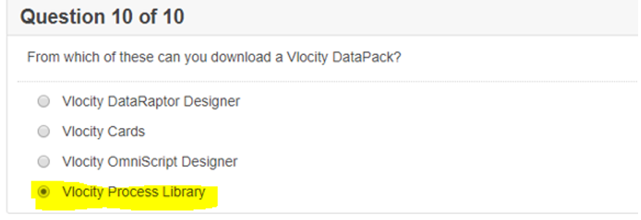

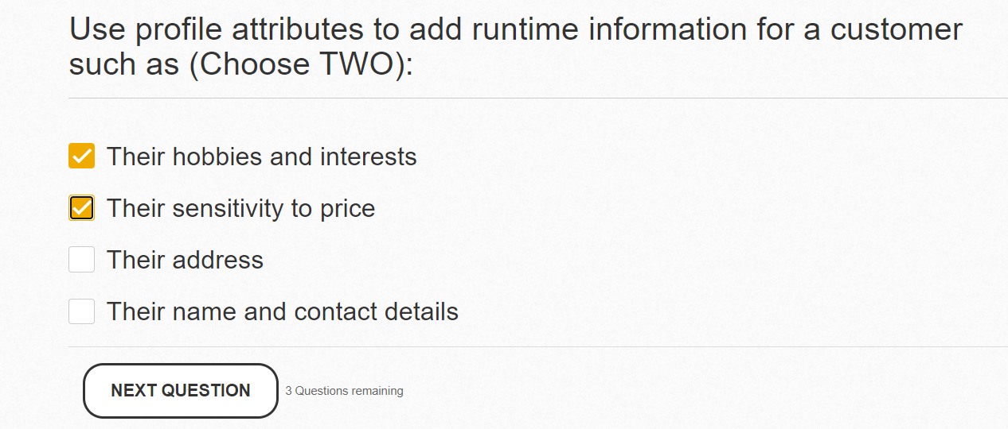

1. 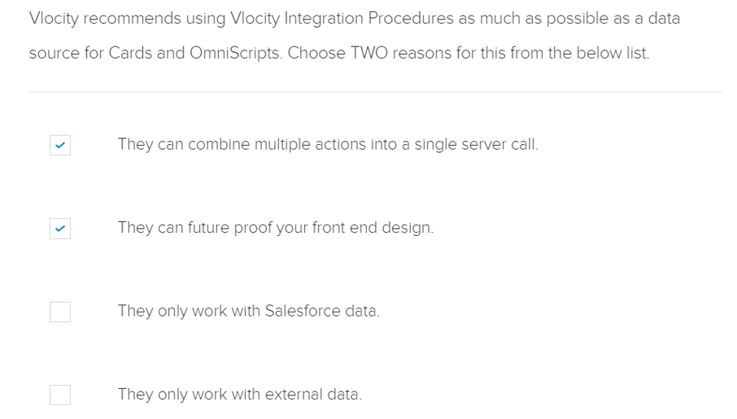
2. 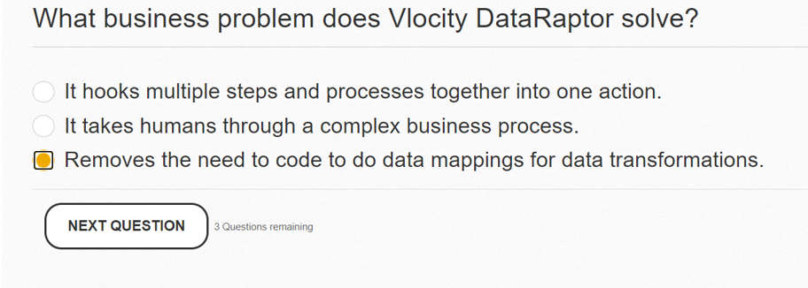
3. 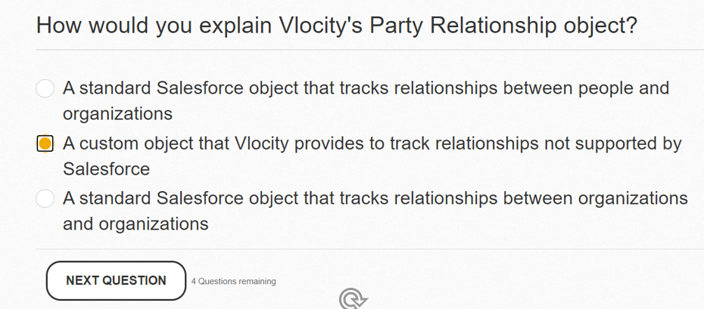
4. 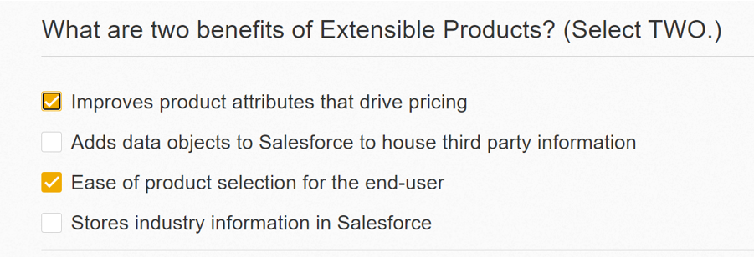
5. 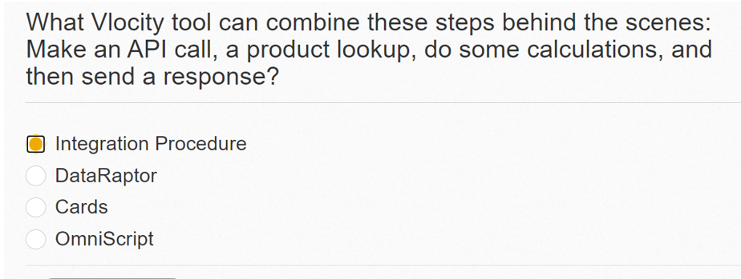
6. Three options has to be selected and options were different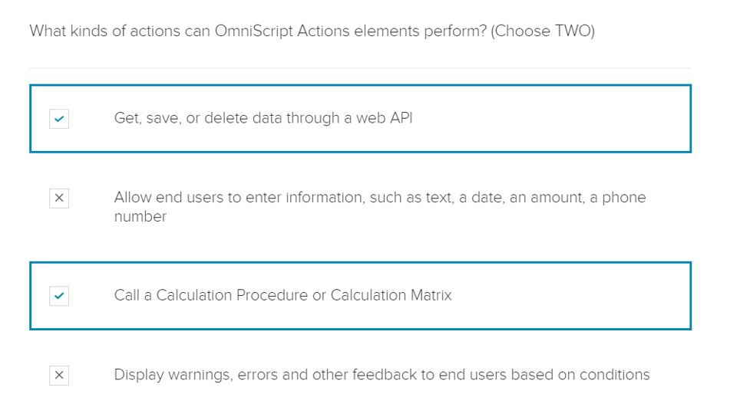
7. 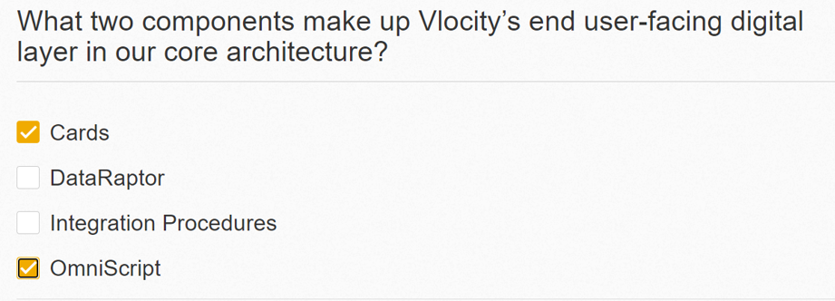
8. 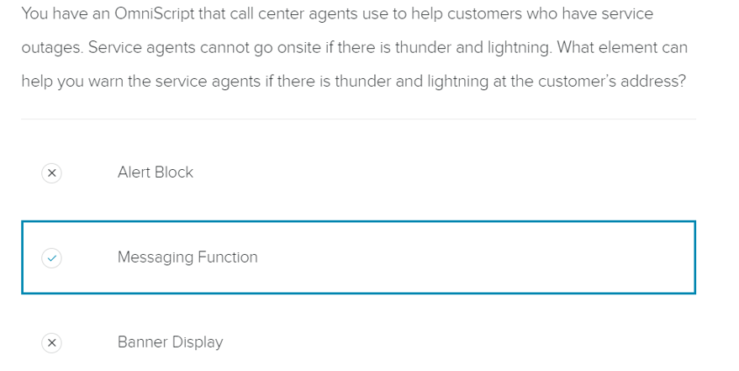
9. 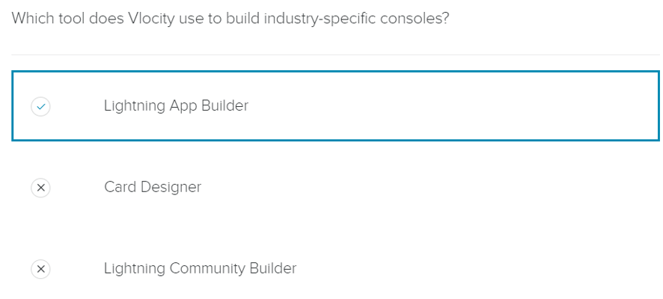

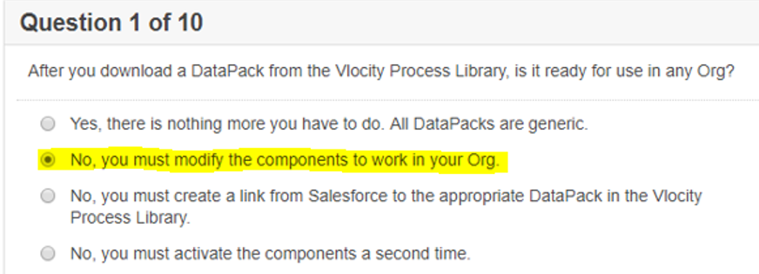

1. Question was what is the best definition of card layout?

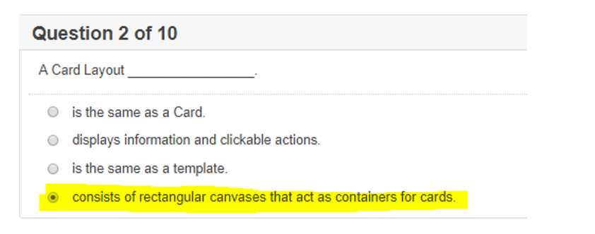

1. 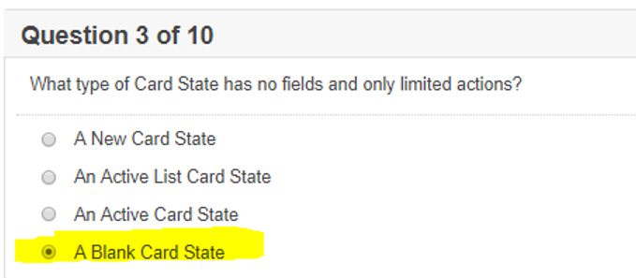
2. Options were bit different –(Don’t select network directories and media files select rest three) 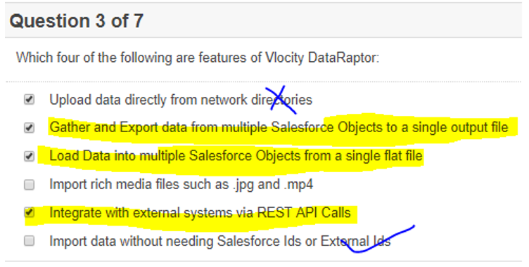
3. 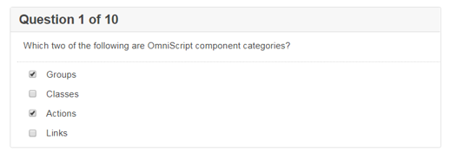
4. 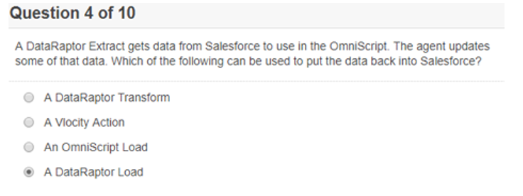
5. 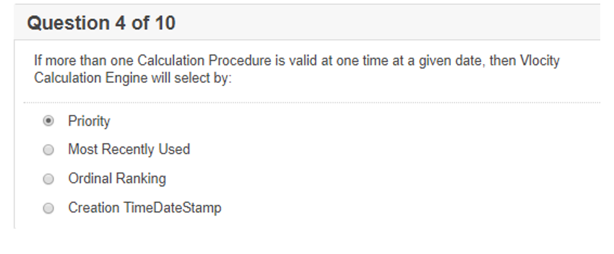
6. Ans- Recalculate Action 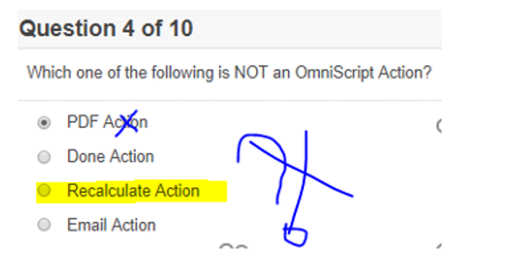
7. 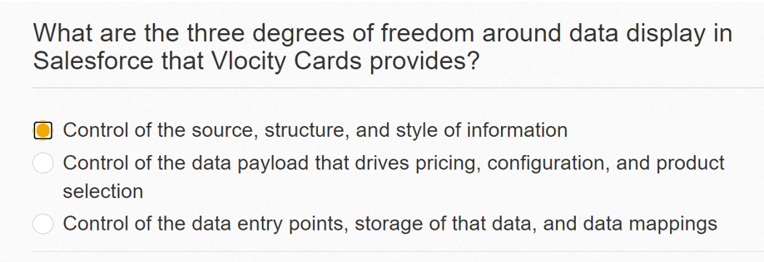
8. Option was given as question and viceversa 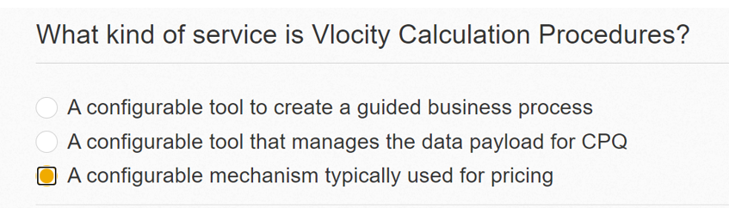

59. **How calculation procedure is different from other configurable mechanisms ?**  
It allows us to use different versions on different timings (In calculation procedure you can define the valid timing for each version that cannot be accomplished for DR's an IP's)